PROGRAM 5 (C02)

AIM : Design a registration activity and store registration details in local memory of phone using SharedPreferences

XML

*<?*xml version="1.0" encoding="utf-8"*?>*<GridLayout xmlns:android="http://schemas.android.com/apk/res/android"  
 xmlns:app="http://schemas.android.com/apk/res-auto"  
 xmlns:tools="http://schemas.android.com/tools"  
 android:id="@+id/Phone"  
 android:layout_width="409dp"  
 android:layout_height="729dp"  
 android:orientation="vertical"  
 tools:context=".MainActivity"  
 tools:layout_editor_absoluteX="1dp"  
 tools:layout_editor_absoluteY="1dp">  
  
 <TextView  
 android:id="@+id/Name"  
 android:layout_width="wrap_content"  
 android:layout_height="wrap_content"  
 android:layout_row="0"  
 android:layout_column="0"  
 android:text="Name" />  
  
 <EditText  
 android:id="@+id/name"  
 android:layout_width="wrap_content"  
 android:layout_height="wrap_content"  
 android:layout_row="0"  
 android:layout_column="1"  
 android:ems="10"  
 android:inputType="textPersonName"/>  
  
 <TextView  
 android:id="@+id/Age"  
 android:layout_width="wrap_content"  
 android:layout_height="wrap_content"  
 android:layout_row="1"  
 android:layout_column="0"  
 android:text="Age" />  
  
 <EditText  
 android:id="@+id/age"  
 android:layout_width="wrap_content"  
 android:layout_height="wrap_content"  
 android:layout_row="1"  
 android:layout_column="1"  
 android:ems="10"  
 android:inputType="textPersonName"/>  
  
 <TextView  
 android:id="@+id/textView4"  
 android:layout_width="wrap_content"  
 android:layout_height="wrap_content"  
 android:layout_row="2"  
 android:layout_column="0"  
 android:text="Phone" />  
  
 <EditText  
 android:id="@+id/phone"  
 android:layout_width="wrap_content"  
 android:layout_height="wrap_content"  
 android:layout_row="2"  
 android:layout_column="1"  
 android:ems="10"  
 android:inputType="phone" />  
  
 <TextView  
 android:id="@+id/Password"  
 android:layout_width="wrap_content"  
 android:layout_height="wrap_content"  
 android:layout_row="3"  
 android:layout_column="0"  
 android:text="Password" />  
  
 <EditText  
 android:id="@+id/pass"  
 android:layout_width="wrap_content"  
 android:layout_height="wrap_content"  
 android:layout_row="3"  
 android:layout_column="1"  
 android:ems="10"  
 android:inputType="textPassword" />  
  
 <Button  
 android:id="@+id/button"  
 android:layout_width="wrap_content"  
 android:layout_height="wrap_content"  
 android:layout_row="4"  
 android:layout_column="1"  
 android:text="Submit" />  
  
</GridLayout>

JAVA

package com.example.sharedpreference;  
  
import android.os.Bundle;  
import android.content.SharedPreferences;  
import android.widget.EditText;  
  
import androidx.appcompat.app.AppCompatActivity;  
  
public class MainActivity extends AppCompatActivity {  
 EditText name,pass,phn,age;  
  
 @Override  
 protected void onCreate(Bundle savedInstanceState) {  
 super.onCreate(savedInstanceState);  
 setContentView(R.layout.*activity_main*);  
 name=(EditText)findViewById(R.id.*name*);  
 pass=(EditText)findViewById(R.id.*pass*);  
 phn=(EditText)findViewById(R.id.*phone*);  
 age=(EditText)findViewById(R.id.*age*);  
  
 }  
 public void onResume() {  
 super.onResume();  
  
 SharedPreferences sh=getSharedPreferences("sp", *MODE_PRIVATE*);  
  
 String s1 = sh.getString("name", "");  
 String s2 = sh.getString("pass", "");  
 int ph = sh.getInt("phone", 0);  
 int a = sh.getInt("age", 0);  
  
 name.setText(s1);  
 pass.setText(s2);  
 phn.setText(String.*valueOf*(ph));  
 age.setText(String.*valueOf*(a));  
  
 }  
 public void onPause() {  
  
  
 super.onPause();  
  
 SharedPreferences sharedPreferences = getSharedPreferences("sp", *MODE_PRIVATE*);  
 SharedPreferences.Editor sp = sharedPreferences.edit();  
  
 sp.putString("name", name.getText().toString());  
 sp.putString("pass", pass.getText().toString());  
 sp.putInt("age", Integer.*parseInt*(age.getText().toString()));  
 sp.putInt("phone", Integer.*parseInt*(phn.getText().toString()));  
 sp.commit();  
 sp.apply();  
 }  
  
}

OUTPUT

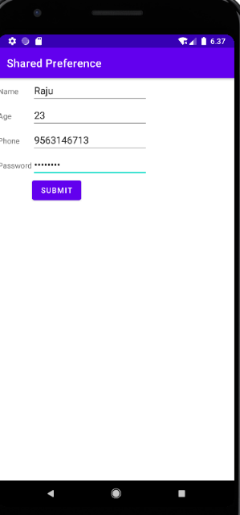

RESULT : Program to store registration using SharedPreference successfully executed and output verified